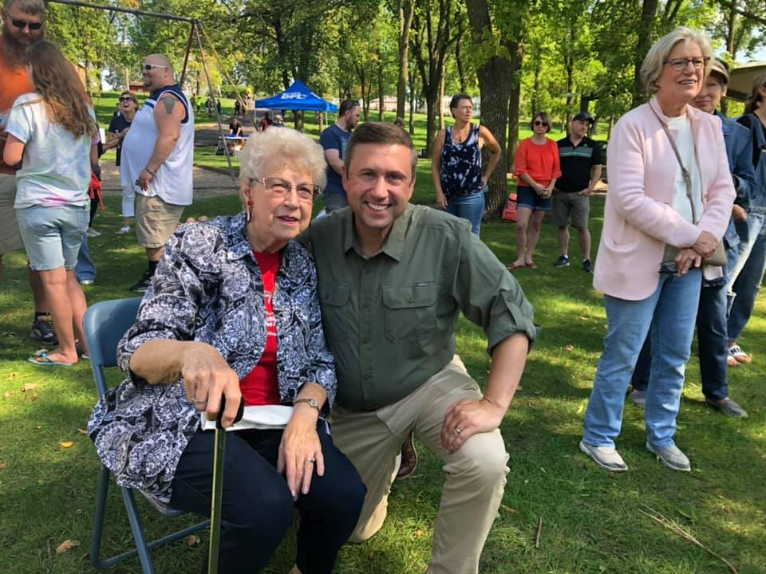
Ken Martin with Lillian Ortendahl

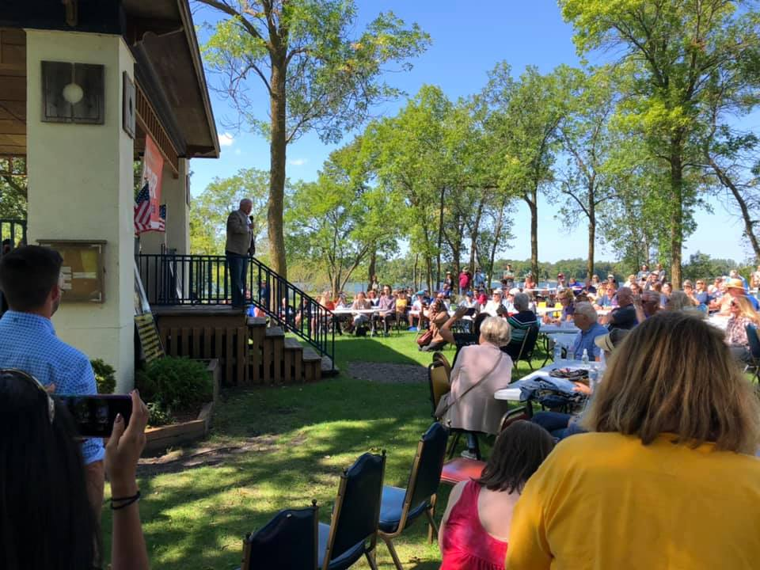
Governor Walz speaking to the audience at Alexandria City Park

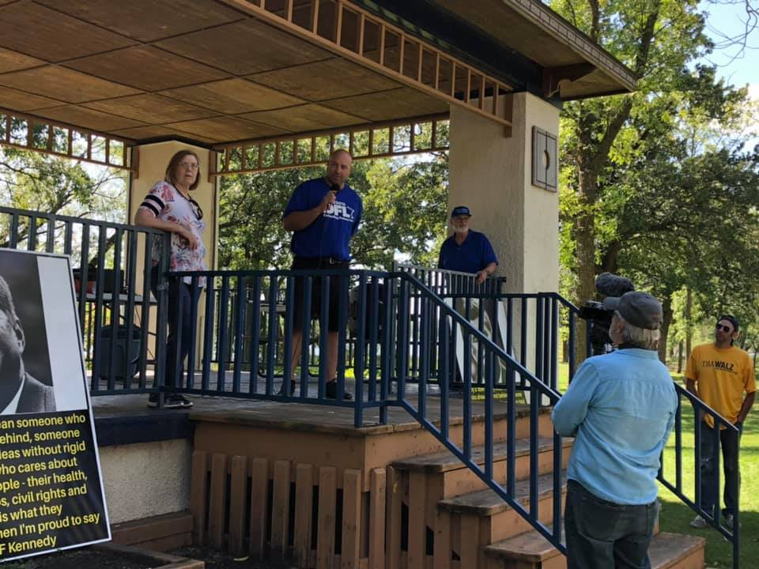
Jason Satter the Chair for Senate District 8
Crowd picture at Alexandria City Park

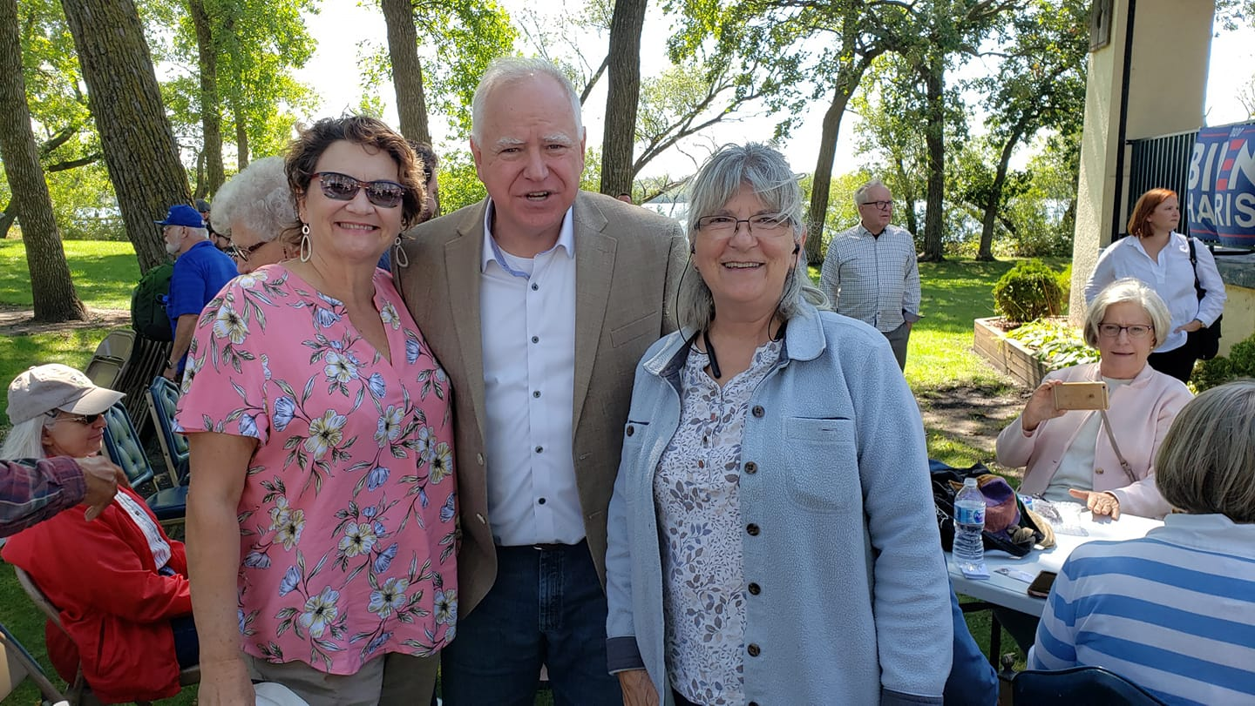
Mary Dahl and Shannon Smith with Governor Walz
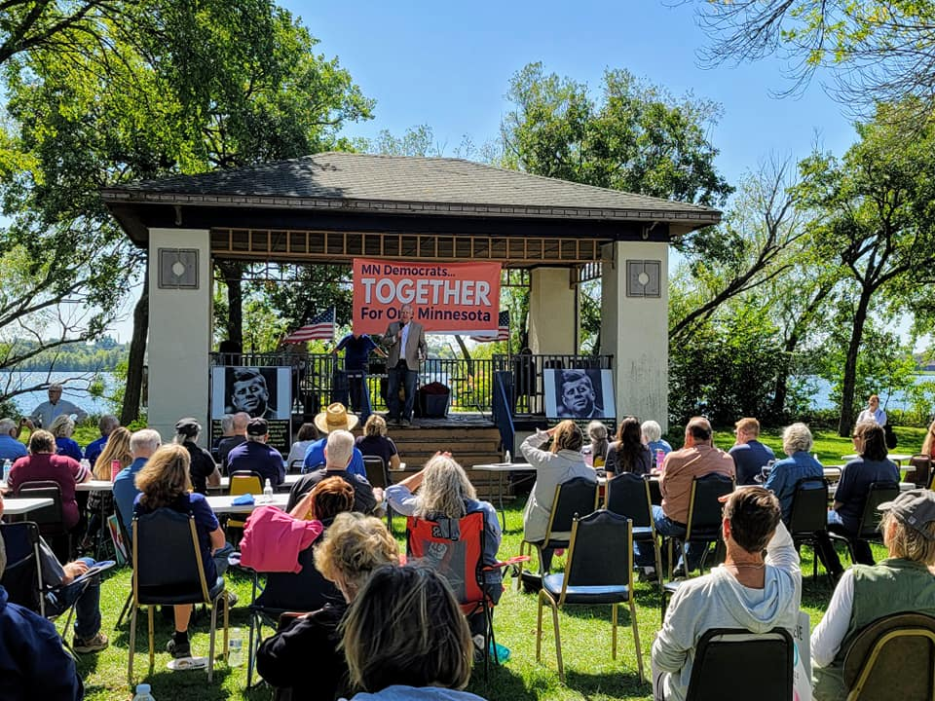
Governor speaking to the Audience

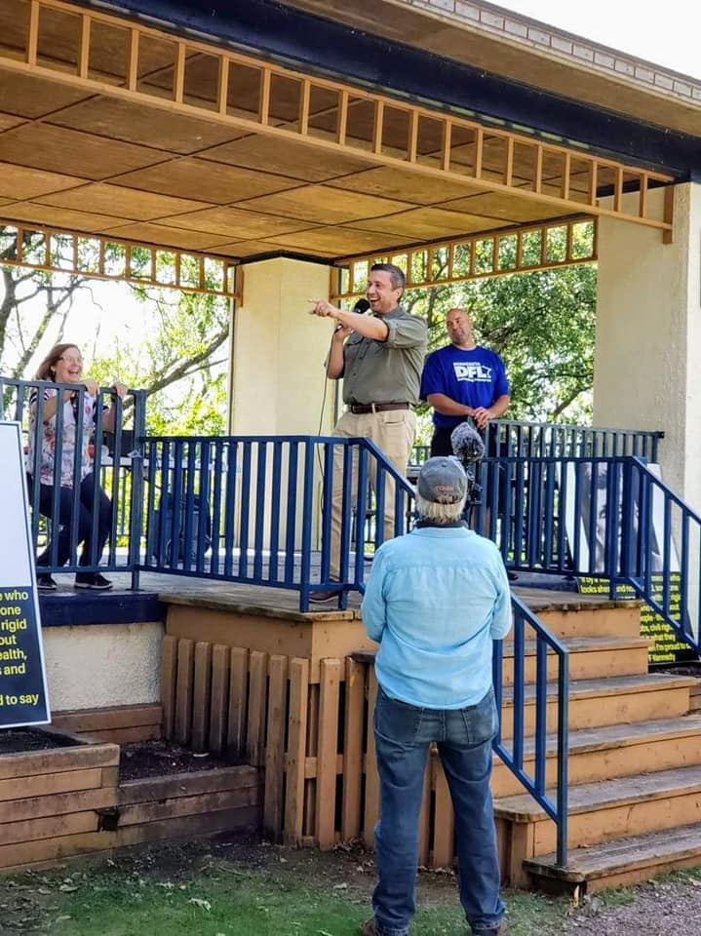
Ken Martin speaking to the Audience
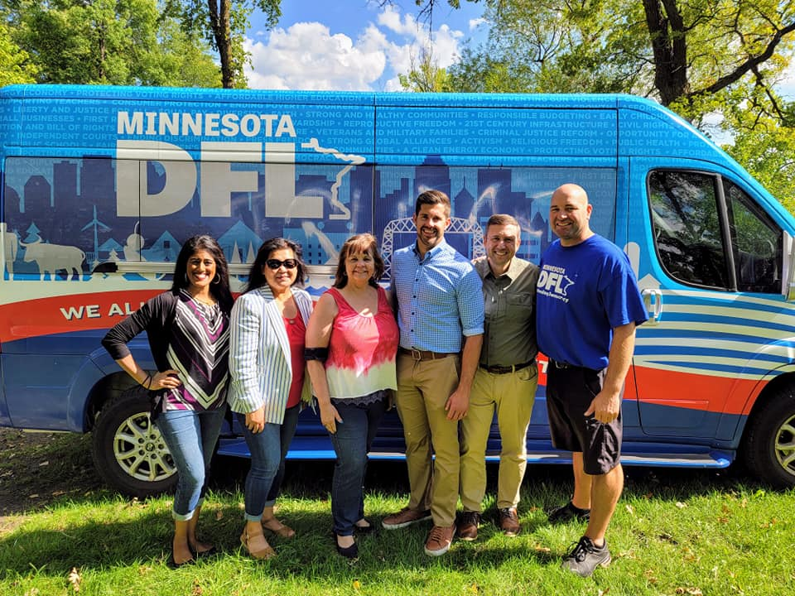
From left to right, Shivanthi Sathanandan 2nd Vice Chair, Kaohly Her State Representative
Marge Hoffa 1st Vice Chair, Dan Wolgamott Assistant Majority Leader 14b, Ken Martin Chairman,
Jason Satter Chair Senate District 8.

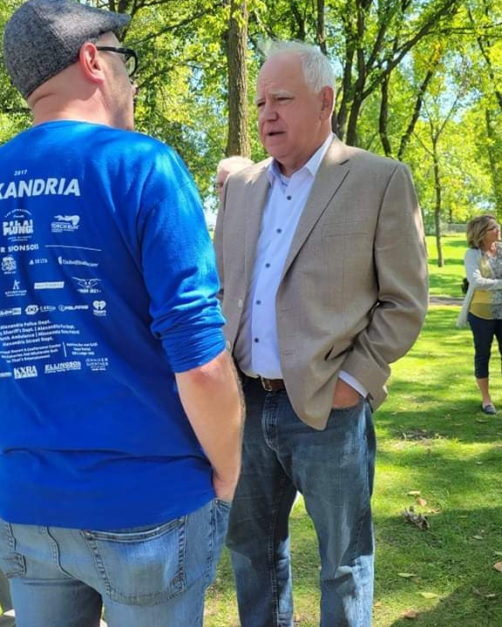
Jeremy Vinar candidate for District 8b talking with
Governor Walz

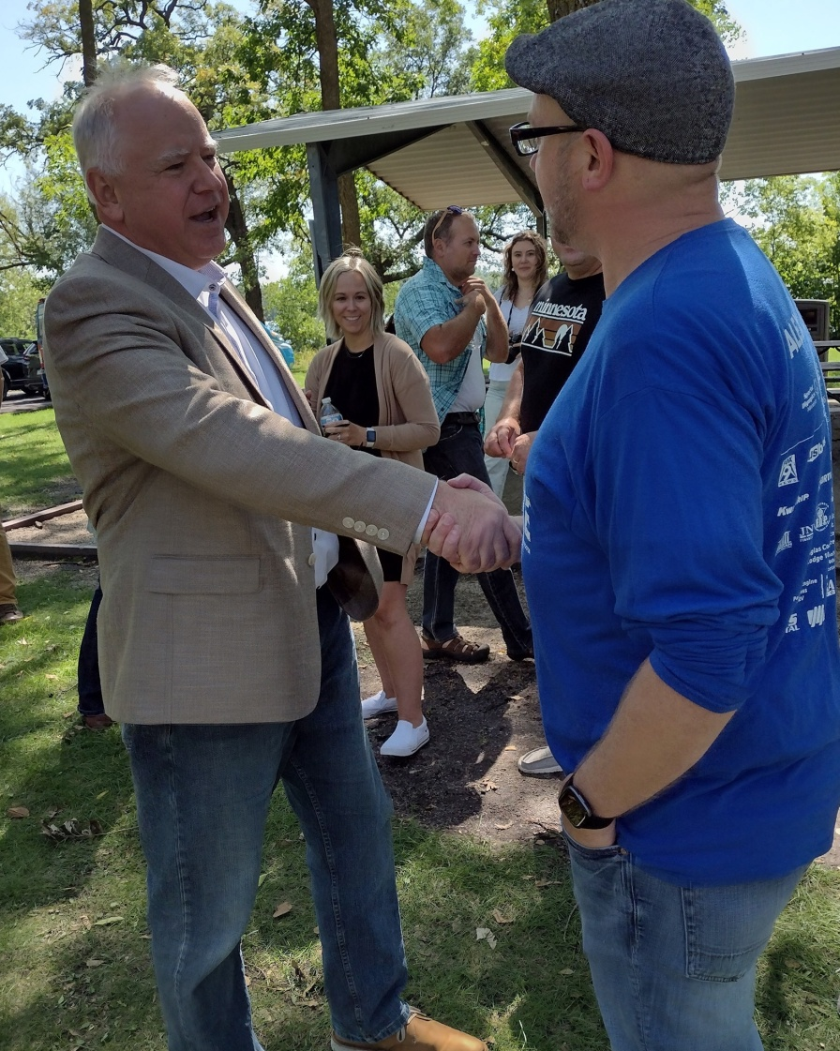
Governor shaking hands with Jeremy Vinar
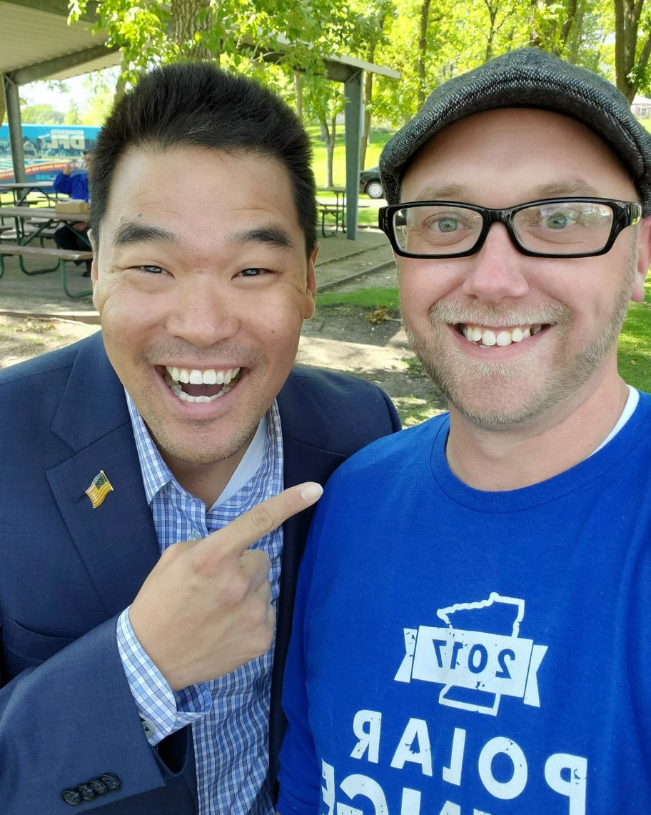
Mark Lindquist and Jeremy Vinar

